Assignment-2

(Dheeraj Tiwari)

Que 1 : 1. Turn LED’s on and off upon user’s choice using if else :- LED1(ON) & LED2(OFF) – when user press 1 on serial monitor LED1(OFF) & LED2(ON) – when user press 2 on serial monitor LED1(ON) & LED2(ON) – when user press 3 on serial monitor BOTH LED GETS OFF – when user press other number on serial monitor.

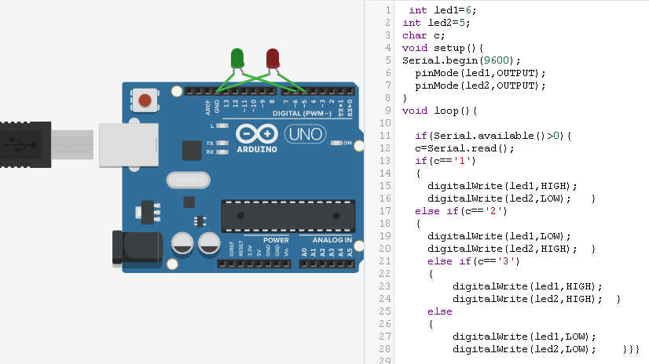

Que2: 2. Take different color LED’s such as RED and YELLOW LED Blink Red led when user provides “red led on” on serial monitor and Yellow led when user provides “yellow led on” on serial monitor using IF-ELSE statement.

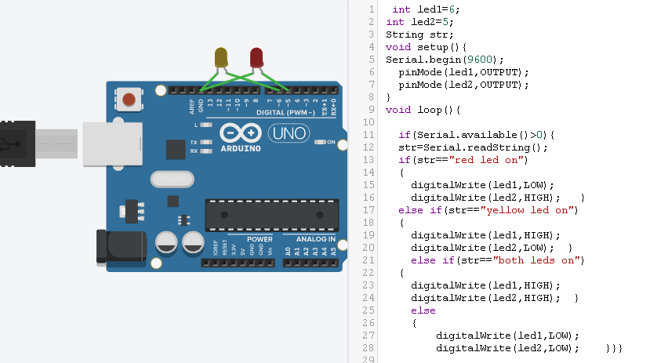

Que 4 : Make a pattern of 6 LED’s using if-else as per following menu:- a. When user gives 1 , LED’s should get blink in forward manner individually b. When user gives 2, LED’s should get blink in reverse manner individually c. When user gives any other number, LED’s should get off together.

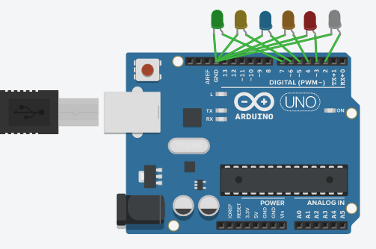

int led1=7;

int led2=6;

int led3=5;

int led4=4;

int led5=3;

int led6=2;

char c;

void setup(){

Serial.begin(9600);

pinMode(led1,OUTPUT);

pinMode(led2,OUTPUT);

pinMode(led3,OUTPUT);

pinMode(led4,OUTPUT);

pinMode(led5,OUTPUT);

pinMode(led6,OUTPUT);

}

void loop(){

if(Serial.available()>0){

c=Serial.read();

if(c=='1')

{

digitalWrite(led1,HIGH);

delay(1000);

digitalWrite(led2,HIGH);

delay(1000);

digitalWrite(led3,HIGH);

delay(1000);

digitalWrite(led4,HIGH);

delay(1000);

digitalWrite(led5,HIGH);

delay(1000);

digitalWrite(led6,HIGH);

delay(1000);

}

else if(c=='2')

{

digitalWrite(led6,LOW);

delay(1000);

digitalWrite(led5,LOW);

delay(1000);

digitalWrite(led4,LOW);

delay(1000);

digitalWrite(led3,LOW);

delay(1000);

digitalWrite(led2,LOW);

delay(1000);

digitalWrite(led1,LOW);

delay(1000); }

else

{

digitalWrite(led1,LOW);

digitalWrite(led2,LOW);

digitalWrite(led3,LOW);

digitalWrite(led4,LOW);

digitalWrite(led5,LOW);

digitalWrite(led6,LOW); }}}